ASSIGNMENT 9

Querying multiple tables at once.

1) Write a query that lists each order number followed by the name of the customer who made the order.
Ans---
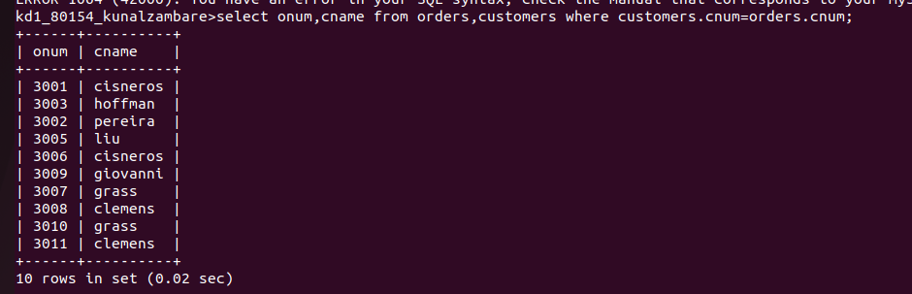

2) Write a query that gives the names of both the salesperson and the customer for each order along with the order number.
Ans--
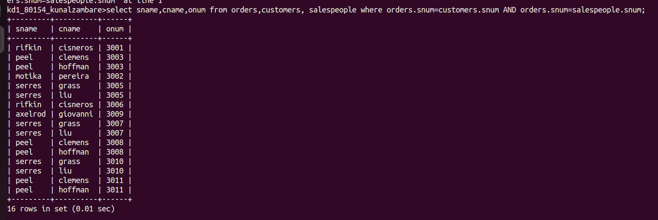

3) Write a query that produces all customers serviced by salespeople with a commission above 12%. Output the customer’s name, the salesperson’s name, and the salespersons rate of commission.
Ans--
Old Style:
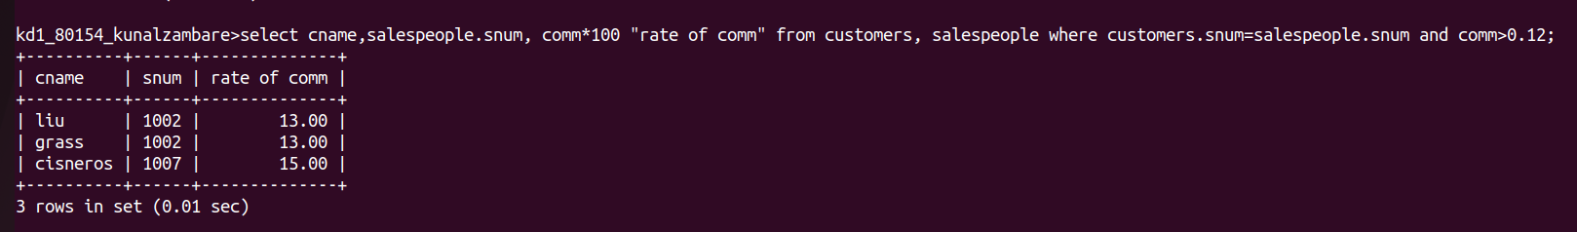
New Style:
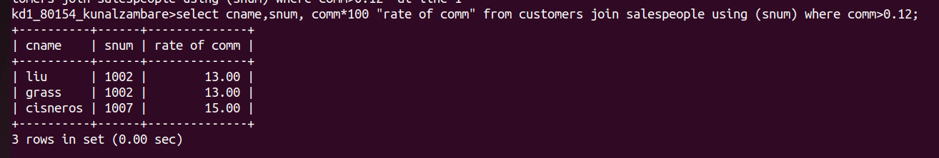

4) Write a query that calculates the amount of the salesperson’s commission on each order by a customer with a rating above 100.
Ans--
